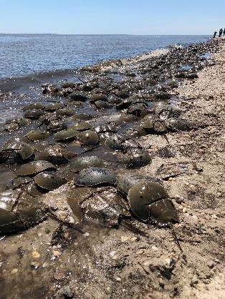
USE OF RECOMBINANT REAGENTS IN BACTERIAL ENDOTOXINS TESTING: TRANSITION FROM LIMULUS AMEBOCYTE LYSATE (LAL)
Recombinant endotoxin test reagents such as recombinant Factor C (rFC) and recombinant Cascade Reagent (rCR) are widely available, reliable, and sustainable alternatives to horseshoe crab blood-derived Limulus Amebocyte Lysate (LAL). Manufactured using the same biotechnology processes as modern medicines, these reagents offer a clear path to transition away from animal-based testing amidst a 30-year decline in horseshoe crab populations.

SUPPLY CHAIN
- Business Continuity: Safeguards the medicine supply chain by eliminating dependence on an unpredictable, wild-harvested natural resource.
- Enhanced Certainty: Mitigates supply chain vulnerabilities driven by external pressures, such as ESA and CITES petitions, federal and state lawsuits and harvesting moratoriums in New York and Connecticut.

QUALITY
- Clear Pathway via USP <86>: The official implementation of USP Chapter <86> establishes a clear, non-animal-derived framework for recombinant testing. For new products, manufacturers can now adopt rFC or rCR directly without needing to demonstrate comparability to traditional LAL methods.
- Global Acceptance: The FDA and global health authorities have approved at least 13 products using rBET across 106 countries, with explicit support or preference voiced by the WHO and global pharmacopeias.
- Proven Performance: Over 15 peer-reviewed studies across nearly 200 real-world pharmaceutical products demonstrate rBET’s equivalence or superiority to LAL, particularly in its high specificity for bacterial endotoxins.
- Consistency: Eliminates the lot-to-lot environmental variability inherent to wild-sourced animal blood by using controlled, validated biotech manufacturing.

COST
- Equipment Compatibility: Transitioning to rCR requires no new capital investment because it is fully compatible with standard plate readers already used for LAL, while choosing rFC may require a modest upfront investment in fluorescence-based readers.
- Rapid ROI: Despite potential initial hardware upgrades for rFC, the long-term operational costs are significantly lower due to reduced reagent expenses and fewer false positives, leading to rapid cost-parity and positive return on investment.

SUSTAINABILITY
- Corporate Alignment: Transitioning to rBET satisfies corporate sustainability goals: the U.N. Sustainable Development Goals, the 3Rs framework (Reduce-Refine-Replace), and investor-driven metrics.
- Biodiversity Impact: Recombinant testing (rBET) provides a synthetic biotechnology solution that protects wild populations and enhances global biodiversity outcomes.
- Species at Risk: The IUCN classifies the American horseshoe crab as "Vulnerable" and the Asian tri-spine as "Endangered". The other two Asian species are likely to be declared endangered in 2026.

A transition to the rBET will help restore horseshoe crabs to ecological carrying capacity and the recovery of threatened shorebird populations and sport fish that depend on horseshoe crab eggs, while maintaining patient safety and the safe supply of medicine. Please take an active role in your organization to facilitate the implementation of rBET as a sustainable alternative to LAL.

