The horseshoe crab has protected our health for decades. Now it’s time to return the favor.

The blood of this ancient sea creature is no longer needed by the biomedical industry.
By Deborah Cramer Updated June 18, 2026, 3:00 a.m.

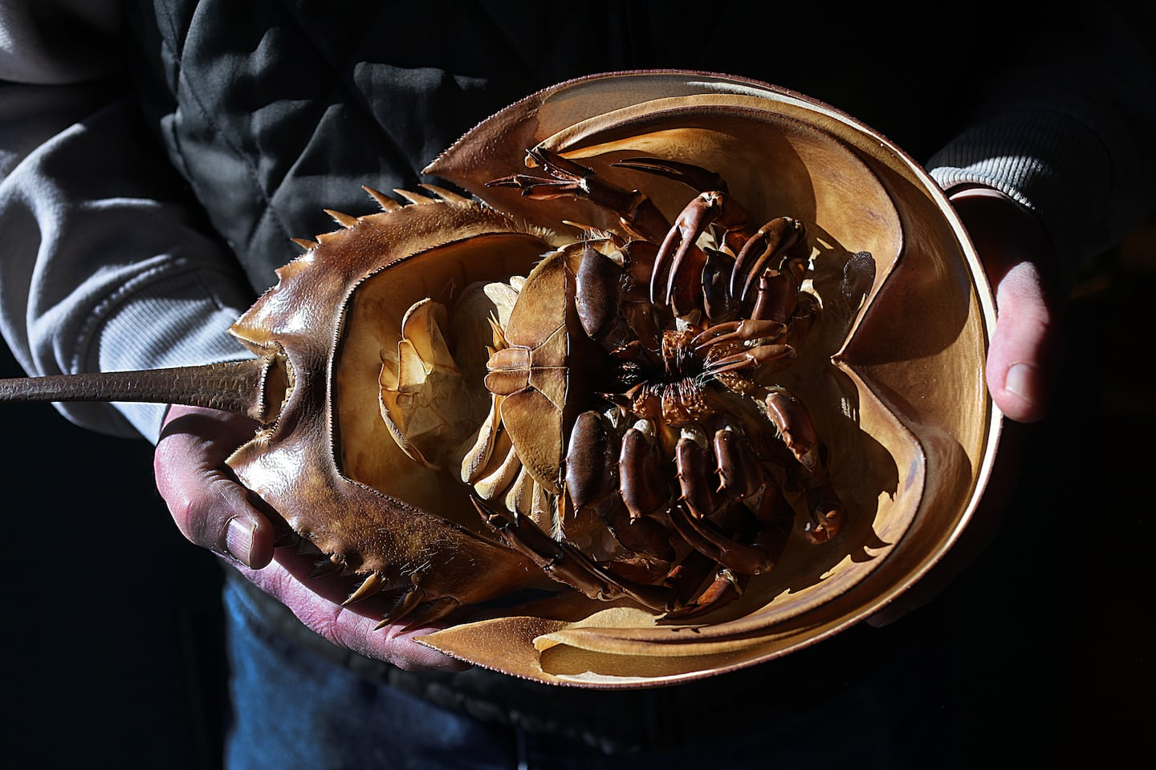The shell of a horseshoe crab.SUZANNE KREITER/GLOBE STAFF
Deborah Cramer is an adviser to the Massachusetts Horseshoe Crab Collaborative and author of “The Narrow Edge: A Tiny Bird, An Ancient Crab, and an Epic Journey.”
Have you ever been vaccinated against COVID-19 or the flu, received intravenous antibiotics or chemotherapy, had a PET scan, a heart stent, or a hip or knee replacement? Chances are you’ve had at least one of these procedures, and if so, an ancient sea creature spared you from a bacterial contaminant so potent it can trigger high fevers, dangerously low blood pressure, septic shock, organ failure, and even death.
That creature, the horseshoe crab, is sustained by blue blood so exquisitely sensitive to endotoxins that it’s used to make a lab test, or assay, that detects them in injectable drugs and vaccines and in medical devices.
For 50 years, our health and well-being have been protected by the horseshoe crab — an animal that’s walked the earth for at least 475 million years. Now, though, its survival is threatened by the demands posed by a rapidly growing pharmaceutical industry. Fortunately, there is a solution. The assay is quickly becoming outdated, and synthetic alternatives are widely available. Massachusetts is in a position to accelerate this transition — if our lawmakers have the will to make it happen.
In the United States, fishermen take a million and a half horseshoe crabs each year. Two-thirds are bled to make endotoxin tests, and the rest are sold for bait. The biomedical catch has surged, more than tripling in the last 20 years. And the demand for endotoxin testing is projected to increase by a further 25 percent by 2030. Massachusetts’s fishing industry has one of the largest horseshoe crab catches on the Eastern Seaboard, and the state is home to two of the world’s largest producers of the horseshoe crab blood assay.
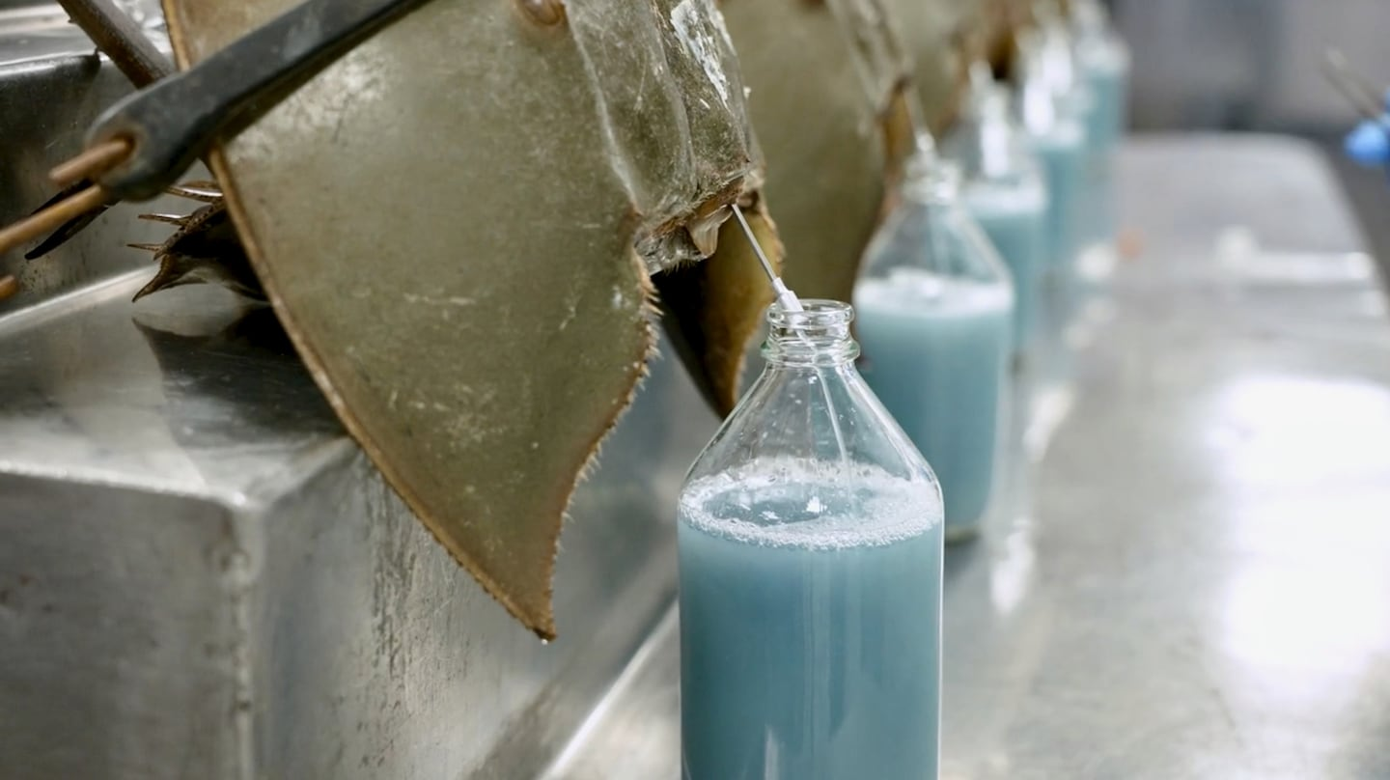Horseshoe crabs being bled at the Charles River Laboratory’s facility in South Carolina.CHARLES RIVER LABORATORIES
In Massachusetts, about 40 percent of the roughly 340,000 horseshoe crabs caught and bled for medical purposes are killed afterward for bait. The rest are thrown back into the water where, dazed and disoriented after losing up to a third of their blood, they no longer sense the rhythm of the tides, and the females may fail to come up onto the beach to lay their eggs.
The consequences to coastal ecosystems are profound. Jennifer Mattei, who studied horseshoe crabs on the Connecticut shore for more than 20 years, found them to be a “dominant” species, with millions needed to sustain a rich array of wildlife at the edge of the sea: Their eggs feed small mummichogs and killifish that, in turn, feed larger stripers and bluefish. Horseshoe crab eggs also fuel the long migrations of large numbers of shorebirds, whose populations are tanking. One bird, the red knot, has been listed as threatened under the Endangered Species Act, largely because it can no longer rely on horseshoe crab eggs for food. The International Union for the Conservation of Nature, which tracks trends in wildlife worldwide, finds that American horseshoe crabs, with few exceptions, no longer fulfill their role nourishing coastal food webs.
The losses are palpable. Beaches once swarming with spawning horseshoe crabs and the seabirds that depend on them for food are empty now, including Pavilion Beach in Ipswich and Ship Yard Beach in Duxbury. And it’s not just their valuable uses in medicine that have caused the population to crash. In the mid-20th century, many towns along the coast of Massachusetts instituted bounty programs to pay fishermen to kill horseshoe crabs, based on the misguided belief that the crabs were insatiable predators of shellfish, putting the crabs in direct competition with the fishermen harvesting bivalves. It’s estimated that at one point up to a million horseshoe crabs were killed annually.
crab fishing continued, first for bait and then for biomedical assays. So many female horseshoe crabs were taken from Pleasant Bay, Cape Cod, that the ratio of male to female horseshoe crabs there skyrocketed to seven, then 14, and then an alarming 30 males to one female. The bounty program ended decades ago, but the crabs have yet to bounce back.
Up where I live, along Essex Bay, a once large horseshoe crab nursery with thousands of young horseshoe crabs — some as tiny as fingernails, others as large as hockey pucks — is virtually empty. Kayaking through the nursery on a calm, windless day at low tide, with a clear view to the bottom, one sees hardly any horseshoe crabs at all.
It is bewildering that Massachusetts continues to allow so many crabs to be taken for biomedical use given the opportunities for widespread synthetic adoption. The US Food and Drug Administration, the World Health Organization, and the European Medicines Agency have all called for nonanimal alternatives in drug testing.
The Pharmaceutical Supply Chain Initiative, a group of more than 80 pharmaceutical companies, has concluded that now “a drug can be guaranteed as safe for use in humans without the need for any horseshoe crab blood.” And the United States and European pharmacopoeias, which set the standards for drug manufacturing here and in Europe, now authorize the use of synthetics. The FDA has already approved their use in new pharmaceuticals, as have its counterparts in 65 countries.
Eli Lilly, one of the world’s largest pharmaceutical companies, headquartered in Indianapolis, is leading the transition to synthetics, thanks to the foresight of Jay Bolden, a biologist and lifelong birder who long ago recognized the plight of shorebirds that depend on horseshoe crab eggs for food. Under his direction, the company replaced 80 percent of its horseshoe crab blood-derived endotoxin tests with synthetic assays. Eli Lilly’s Emgality, an injection to prevent migraines, and Mounjaro and Zepbound, weight loss and diabetes medicines, are being tested for endotoxins using a synthetic assay.
Other pharmaceutical companies are following Eli Lilly’s lead: By 2025, Bristol Myers Squibb had reduced its use of horseshoe crab-derived assays in its New Jersey plant by 99 percent, and Bayer has received approval for a new tracer (used in medical imaging like CT scans and MRIs) from the FDA. Both of these companies are using synthetics developed by companies based in Massachusetts.
Synthetics can’t yet replace a very small number of diagnostic tests dependent upon horseshoe crab blood. Until they can, states whose horseshoe crab populations are far more robust than ours, whose coastal ecosystems are not yet as diminished, can supply the few thousand horseshoe crabs necessary for these tests.
In a recent survey of pharmaceutical companies, more than half said synthetics will become the industry standard, and half expect to make the transition in the next two to three years. The Connecticut and New York legislatures, for their part, have already banned horseshoe crab fishing in their states. It’s time for Massachusetts to do the same.
Massachusetts lawmakers have an opportunity to do this — a proposal working its way through the legislature, if passed, would pave the way for the widespread use of synthetics and spell an end to horseshoe crab fishing in the state by January 1, 2029, mirroring the timetable in New York and halting what has become an indefensible cruelty to animals. “Protecting [our lands, water, and wildlife] isn’t optional – it’s essential,” Governor Maura Healy declared, when last August, she launched the nation’s most ambitious plan to restore and protect biodiversity. The legislation in progress would provide a powerful implementation of that vision.
Major conservation, birding, and animal rights organizations are lining up to support this bill. Whelk fishermen oppose it, arguing that horseshoe crabs are needed as bait — but there are alternative baits for catching whelk, including the green crab, a notorious invasive species in Massachusetts. And in fact, whelk fishing has declined dramatically in recent years due to overharvesting, so there’s little demand for bait anyway. Rather, bait dealers “rent” crabs to biomedical companies for bleeding, propping up a bait fishery where demand is so low that bait horseshoe crabs sell for as little as 25 cents apiece.
With the passage of this legislation, our now silent seashore would teem with wildlife once again, with horseshoe crabs returning en masse to lay their eggs on warm, moonlit nights and flocks of shorebirds scurrying across the sand by day. In the Monomoy National Wildlife Refuge, where a lawsuit prohibited the take of horseshoe crabs for biomedical use 25 years ago, we’re seeing a glimpse of what’s possible: Horseshoe crabs are beginning to return, and with them, little by little, shorebirds too — red knots, ruddy turnstones, and even a Hudsonian godwit.
For decades, horseshoe crabs have protected our health. Now it’s time for us to return the favor and protect theirs.

